# 1. Write a query to count the number of codes in each group.

SELECT group_code, count(*) as Count
FROM HCPCS.hcpcs_codes
GROUP BY group_code;

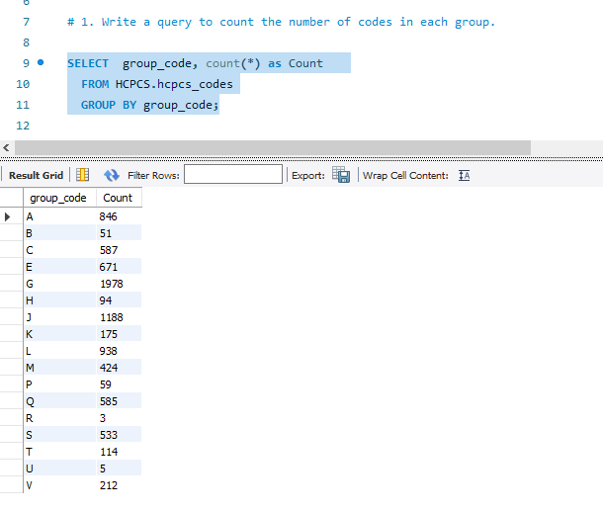

# 2. Show the top 5 categories with the highest number of codes.

SELECT category_name
FROM
(SELECT group_code,
category_name,
COUNT(*) AS Count
FROM HCPCS.hcpcs_codes
GROUP BY group_code, category_name
ORDER BY Count DESC
) AS Sub
LIMIT 5;
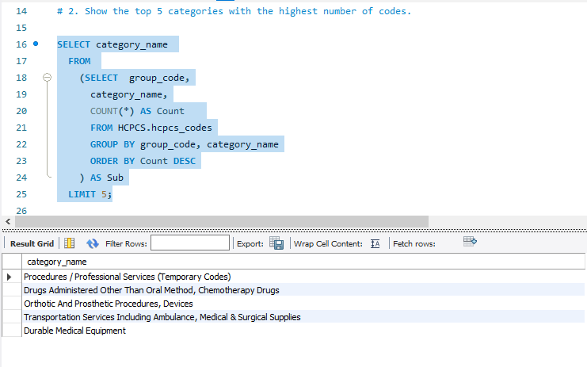

# 3. Find all codes that have changed descriptions over time (same hcpcs_code, different long_description).

SELECT hcpcs_code
FROM
(SELECT hcpcs_code,
COUNT(DISTINCT long_description) AS versions
FROM hcpcs_codes
GROUP BY hcpcs_code
HAVING COUNT(DISTINCT long_description) > 1
AND MAX(is_current) = 'Y'
) AS Sub;

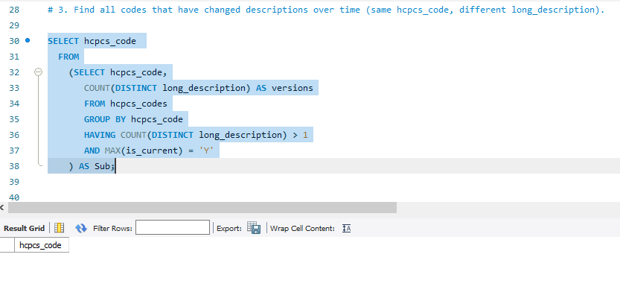

# 4. Show codes that were active in 2022 but expired before 2024.
SELECT *
FROM hcpcs_codes
WHERE effective_date <= '2022-12-31'
AND end_date IS NOT NULL
AND end_date < '2024-01-01';

